Logbook (Week 1-12)

Industrial Training Activity
(This cover page is an example, students can have own design for this cover page.)

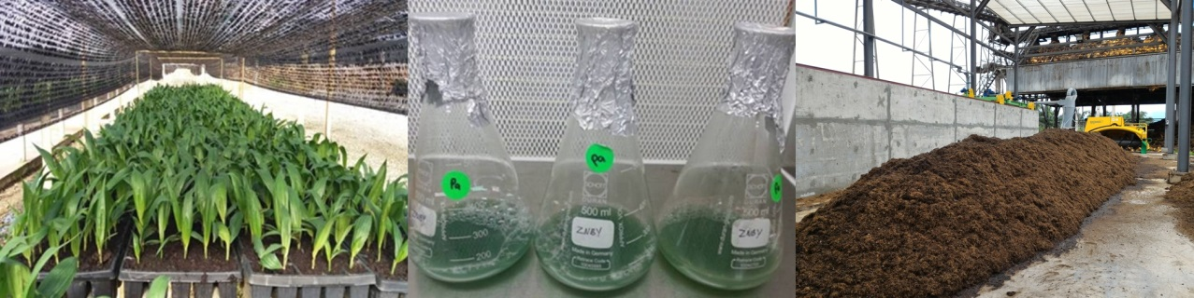

Faculty of Biotechnology
and Biomolecular Sciences
WEEK 1
ACTIVITY

REMARKS AND ENDORSEMENT BY INDUSTRIAL SUPERVISOR

(SIGNATURE & CHOP/STAMP)

DATE:

WEEK 2
ACTIVITY

REMARKS AND ENDORSEMENT BY INDUSTRIAL SUPERVISOR

(SIGNATURE & CHOP/STAMP)

DATE:

WEEK 3
ACTIVITY

REMARKS AND ENDORSEMENT BY INDUSTRIAL SUPERVISOR

(SIGNATURE & CHOP/STAMP)

DATE:

WEEK 4
ACTIVITY

REMARKS AND ENDORSEMENT BY INDUSTRIAL SUPERVISOR

(SIGNATURE & CHOP/STAMP)

DATE:

WEEK 5
ACTIVITY

REMARKS AND ENDORSEMENT BY INDUSTRIAL SUPERVISOR

(SIGNATURE & CHOP/STAMP)

DATE:

WEEK 6
ACTIVITY

REMARKS AND ENDORSEMENT BY INDUSTRIAL SUPERVISOR

(SIGNATURE & CHOP/STAMP)

DATE:

WEEK 7
ACTIVITY

REMARKS AND ENDORSEMENT BY INDUSTRIAL SUPERVISOR

(SIGNATURE & CHOP/STAMP)

DATE:

WEEK 8
ACTIVITY

REMARKS AND ENDORSEMENT BY INDUSTRIAL SUPERVISOR

(SIGNATURE & CHOP/STAMP)

DATE:

WEEK 9
ACTIVITY

ENDORSEMENT BY INDUSTRIAL SUPERVISOR

(SIGNATURE & CHOP/STAMP)

DATE:

WEEK 10
ACTIVITY

REMARKS AND ENDORSEMENT BY INDUSTRIAL SUPERVISOR

(SIGNATURE & CHOP/STAMP)

DATE:

WEEK 11
ACTIVITY

REMARKS AND ENDORSEMENT BY INDUSTRIAL SUPERVISOR

(SIGNATURE & CHOP/STAMP)

DATE:

WEEK 12
ACTIVITY

REMARKS AND ENDORSEMENT BY INDUSTRIAL SUPERVISOR

(SIGNATURE & CHOP/STAMP)

DATE:

